The Use of Drones in Pasture Weed Management

Brent Sellers and Tenzy Mncube

Aerial pesticide applications are not new to the agriculture industry, but this type of application has increased in popularity due to improved technology of unmanned aerial vehicles (UAVs, drones, etc.; Figure 1). As with any new technology, many of us have questions regarding the application and effectiveness of herbicides using drones. Considering that most of us are used to sprayer outputs of at least 20 gallons per acre (GPA), it makes many of us uneasy about herbicide effectiveness when many drone applications are going out at less than 5 GPA.

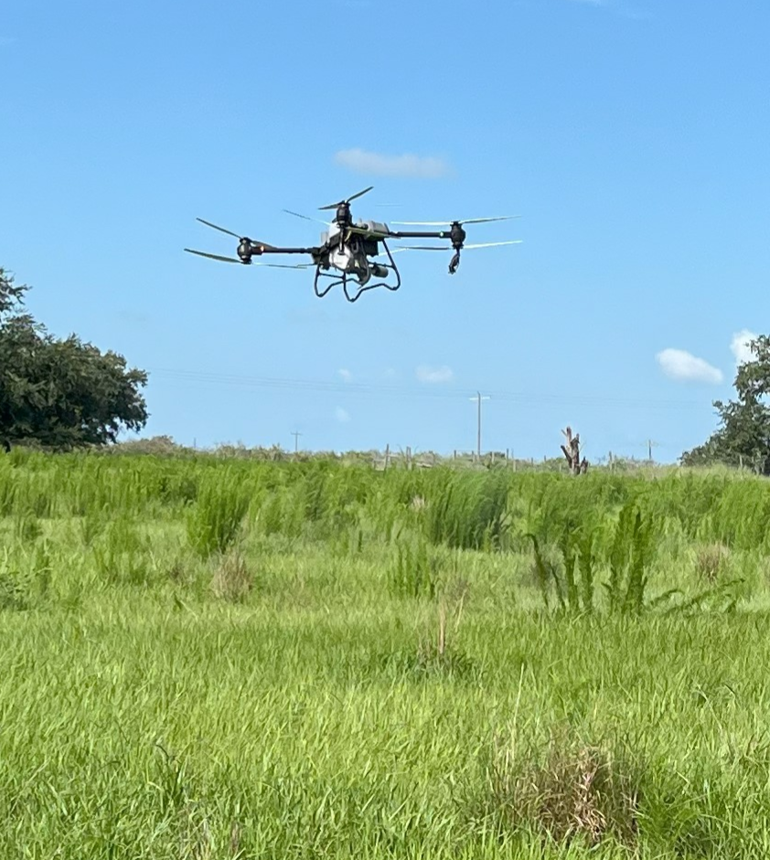
Figure 1. Unmanned Aerial Vehicles (UAVs), commonly known as drones, are increasingly being utilized for pesticide applications in agriculture.

First, we must look at the herbicide label to make sure that aerial applications are even allowable for a particular herbicide. A quick search of pasture herbicide labels reveals that almost all herbicides utilized for pasture weed control can be applied aerially (Table 1), with the only exception being hexazinone (Tide Hexazinone, Velossa, Velpar) in pastures. The applicator must follow the label restrictions, and most of them indicate that applications should not occur more than 10 ft above the crop canopy and mitigate spray drift as much as possible (each label has specific requirements).

Table 1. Common pasture herbicides with label-specified sprayer output volumes for aerial applications in pastures.
Trade name! | Active ingredient(s) | Aerial application  allowed? | Sprayer output²
DuraCor | aminopyralid + florpyrauxifen benzyl | Yes | ≥ 2 GPA
GrazonNext HL | aminopyralid + 2,4-D | Yes | ≥ 2 GPA
Pasturegard HL | fluroxypyr + triclopyr | Yes | ≥3 GPA
Weedmaster | dicamba + 2,4-D | Yes | 3 to 10 GPA
Remedy Ultra | triclopyr | Yes | ≥ 2 GPA
MSM60 | metsulfuron | Yes | 2 to 5 GPA
NovaGraz | florpyrauxifen-benzyl + 2,4-D | Yes | ≥ 2 GPA
Outrider | sulfosulfuron | Yes | 5 to 15 GPA
Hexazinone | hexazinone | No | N/A
Chaparral | aminopyralid + metsulfuron | Yes | ≥ 2 GPA
Panoramic | imazapic | Yes | ≥ 2 GPA
Milestone | aminopyralid | Yes | ≥ 2 GPA
Rezilon | indaziflam | Yes | ≥ 5 GPA
Telar | chlorsulfuron | Yes | ≥3 GPA
Pastora | metsulfuron + nicosulfuron | Yes | ≥ 2 GPA
¹Although there are various trade names for the same active ingredient(s), it is best practice to consult the label for the specific trade name to ensure that label directions are followed.
² GPA = gallons per acre

Rather than go into further legalities and regulations surrounding the use of drones for pesticide applications (for regulatory requirements regarding pesticide applications with drones, please visit https://edis.ifas.ufl.edu/publication/AE608), we want to ensure that this technology will work for herbicides that we commonly use in pastures.

In July 2024, we set up an experiment to compare ground applications of DuraCor + Pasturegard HL (16 oz/A + 16 oz/A) or GrazonNext HL + Pasturegard HL (24 oz/A + 16 oz/A) at sprayer outputs of 10, 20, or 30 GPA with drone applications of these same herbicides and rates at an output of 2.5 GPA. The primary weed in the pasture was dogfennel at an average height of 36 inches.

Analyzing the data from this trial was easy. We saw no visible differences between the ground application vs. the aerial application at 1 and 2 months after treatment (Figure 2). We also put the drone application to the test on an abandoned citrus grove with dogfennel exceeding 7 ft in height, and there were controlled using these herbicide mixes.

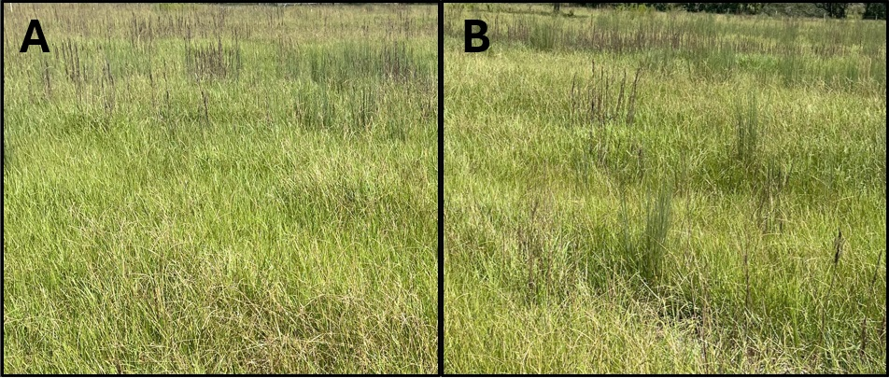
Figure 2. Comparison of DuraCor + Pasturegard HL (16 oz/A + 16 oz/A) applied with a ground sprayer at 20 gallons per acre (A) or a drone at 2.5 gallons per acre (B).

Our preliminary research indicates that drones could be utilized for pasture weed control and are just as effective as ground applications. However, we will hold back on recommendations until we have at least another year of data. Further, we may start looking at reduced herbicide rates, allowing for reduced weed management costs. Currently, drone applications cost at least $5 more per acre than a traditional ground application. However, drones can also be utilized to spray areas where ground equipment can’t always go due to terrain and can also save wear and tear on ground equipment when driving through the never-ending hog rooting and smutgrass.

Acknowledgement: We would like to thank Hugh MacDonald and Chase Haley of Precision Agricultural Services for their assistance with the drone applications in our studies.

